**AKHUWAT COLLEGE KASUR AFFILIATED WITH**

**UNIVERSITY OF THE PUNJAB, LAHORE.**

**FINAL YEAR PROJECT (FYP)**

**DELIVERABLE-01: SOFTWARE REQUIREMENT SPECIFICATION**

**PROJECT TITLE**

**AI-DRIVEN SECURITY MONITORING: ANOMALY DETECTION IN ELK AND WAZUH**

**BS (IT)**

**SESSION: 2021-2025**

**GROUP MEMBERS**

Khalid Hussain 058960

Muhammad Osama 058949

**SUPERVISED BY:**

EBRYX TEAM

**&**

MR. MUHAMMAD NAEEM AKHTAR

**Table of Contents**

1. Executive Summary 3

2. Requirements Analysis 3

2.1 User Classes and Characteristics 3

2.2 Requirement Identification Techniques 3

3. Functional Requirements 4

3.1 System Features 4

3.2 Detailed Functional Requirements 4

4. Non-Functional Requirements 8

4.1 Reliability 8

4.2 Speed and Performance 8

4.3 Compatibility 8

4.4 Scalability 8

4.5 Maintainability 8

5. External Interfaces 9

5.1 User Interface 9

5.2 Software Interfaces 9

5.3 Hardware Requirements 9

5.4 Communication 9

6. Use Case Analyses 10

6.1 Use Case 1: Anomalous File Creation Detection 10

6.2 Use Case 2: Suspicious Login Attempt Detection 11

7. Use Case Diagram 12

9. Summary 13

## 1. Executive Summary

This document outlines the requirements for an AI-powered anomaly detection system built using Wazuh and the Elastic Stack (Elasticsearch, Logstash, Kibana). The system monitors security logs to identify unusual activities, such as:

* **Anomalous File Creation**: Detecting unauthorized or suspicious file creation in restricted directories.
* **Suspicious Login Attempts**: Identifying too many failed login attempts that may indicate brute-force attacks.

The system will use Artificial Intelligence (AI)/Machine Learning (ML) to automatically detect anomalies, provides real-time alerts, and visualizes data on user-friendly Kibana dashboards for security analysts to investigate and respond effectively.

## 2. Requirements Analysis

This section details the system’s requirements, including user needs, constraints, and key features, based on thorough analysis.

### 2.1 User Classes and Characteristics

| **User Class** | **Characteristics** |
| --- | --- |
| **Security Analysts** | Monitor logs, review alerts, investigate incidents, and take corrective actions. |
| **System Administrators** | Configure and maintain Wazuh and Elastic Stack components, manage system uptime. |
| **AI/ML Engineers** | Develop, train, and optimize AI/ML models for anomaly detection. |

### 2.2 Requirement Identification Techniques

Requirements were gathered using the following methods:

* **Use Case Analysis**: Developed detailed use cases and diagrams to map system interactions and features, ensuring alignment with user needs.
* **Stakeholder Interviews**: Consulted security teams and IT staff to understand practical security challenges and system expectations.
* **Data-Driven Analysis**: Examined real-world security logs to define performance for AI/ML anomaly detection.
* **Literature Review**: Studied research papers on AI-based security systems to adopt best practices and address potential challenges.

## 3. Functional Requirements

### 3.1 System Features

The system provides the following core functionalities:

| **ID** | **Feature** | **Description** |
| --- | --- | --- |
| **FR-1** | Log Collection | Collects security logs from devices and applications in real-time. |
| **FR-2** | AI-Based Anomaly Detection | Uses AI/ML to identify unusual patterns in logs (e.g., anomalies). |
| **FR-3** | Alert System | Sends real-time alerts when threats or anomalies are detected. |
| **FR-4** | Dashboard Visualization | Displays security data on Kibana dashboards with graphs and filters. |
| **FR-5** | Anomalous File Creation Detection | Detects and alerts on unauthorized or suspicious file creation events. |
| **FR-6** | Suspicious Login Attempt Detection | Monitors and alerts on too many failed login attempts within a short period. |
| **FR-7** | Alert Customization | Allows users to set custom alert thresholds and response actions. |
| **FR-8** | Incident Reporting | Enables logging and documentation of incidents for analysis and compliance. |

### 3.2 Detailed Functional Requirements

|  |  |
| --- | --- |
| **Identifier** | **FR-1** |
| **Title** | Log Collection |
| **Requirement** | The system shall collect security logs from various devices and applications. |
| **Source** | Need for security monitoring from endpoint. |
| **Rationale** | Helps detect security threats by analyzing logs in one place. |
| **Business Rule** | Alerts should be generated if a file is created in a restricted directory or by an unauthorized user. |
| **Dependencies** | None |
| **Priority** | High |

|  |  |  |  |  |  |  |  |  |  |  |  |  |  |  |  |  |
| --- | --- | --- | --- | --- | --- | --- | --- | --- | --- | --- | --- | --- | --- | --- | --- | --- |
| |  |  | | --- | --- | | **Identifier** | **FR-2** | | **Title** | AI-Based Detection | | **Requirement** | The system shall use AI to detect unusual activities in collected logs. | | **Source** | Requirement for advanced threat detection. | | **Rationale** | Identifies hidden threats not caught by standard rules. | | **Business Rule** | The AI model should analyze logs in real-time and flag unusual patterns. | | **Dependencies** | FR-1 *(Log Collection)* | | **Priority** | High | |
|  |  | |
|  |  | |
|  |  | |
|  |  | |
|  |  | |
| |  |  | | --- | --- | | **Identifier** | **FR-3** | | **Title** | Alert System | | **Requirement** | The system shall send alerts when a potential security threat is detected. | | **Source** | Requirement for quick threat notification. | | **Rationale** | Enables fast response to potential security issues. | | **Business Rule** | Alerts should be sent via email and displayed on the dashboard. | | **Dependencies** | FR-2 *(AI-Based Detection)* | | **Priority** | High | | |
|  | |
|  | |
|  | |
|  | |
| |  |  | | --- | --- | | **Identifier** | **FR-4** | | **Title** | Dashboard | | **Requirement** | The system shall present security data in a clear and easy-to-understand format | | **Source** | Need for accessible security monitoring. | | **Rationale** | Allows security teams to monitor the system effectively. | | **Business Rule** | The dashboard should display alerts, logs, and system status. | | **Dependencies** | FR-1 *(Log Collection),* FR-3 *(Alert System)* | | **Priority** | High | | |
|  | |
|  | |
|  | |
|  | |
|  | |
|  | |

|  |  |  |  |  |  |  |  |  |  |  |  |  |  |  |  |  |
| --- | --- | --- | --- | --- | --- | --- | --- | --- | --- | --- | --- | --- | --- | --- | --- | --- |
| |  |  | | --- | --- | | **Identifier** | **FR-5** | | **Title** | Anomalous File Creation Detection | | **Requirement** | The system shall detect and alert users about unusual file creation activities based on AI analysis. | | **Source** | Security monitoring needs from Wazuh logs. | | **Rationale** | Helps security analysts detect potential security threats in real time. | | **Business Rule** | Alerts should be generated if a file is created in a restricted directory or by an unauthorized user. | | **Dependencies** | FR-1 *(Log Collection),* FR-2 *(AI-Based Detection)* | | **Priority** | High | |
|  |  |
|  |  |
|  |  |
|  |  |
|  |  |

|  |  |
| --- | --- |
| **Identifier** | **FR-6** |
| **Title** | Suspicious Login Attempt Detection |
| **Requirement** | The system shall monitor and identify **too many failed** login attempts from a single user or IP address within a short time frame. |
| **Source** | Security policy for monitoring unauthorized access attempts. |
| **Rationale** | Prevents brute-force attacks and helps in identifying compromised accounts. |
| **Business Rule** | The system should generate alerts if failed login attempts 5 within a minute. |
| **Dependencies** | FR-1 *(Log Collection),* FR-3 *(Alert System)* |
| **Priority** | High |

|  |  |
| --- | --- |
| **Identifier** | **FR-7** |
| **Title** | Alert Customization |
| **Requirement** | The system shall allow users to configure alert rules and response actions. |
| **Source** | Need for customized security management |
| **Rationale** | Enables flexibility in responding to specific threats. |
| **Business Rule** | Users should be able to set custom thresholds and choose alert methods. |
| **Dependencies** | FR-3 *(Alert System)* |
| **Priority** | Low |

|  |  |
| --- | --- |
| **Identifier** | **FR-8** |
| **Title** | Incident Reporting |
| **Requirement** | The system shall enable security analysts to log incidents and document investigation details. |
| **Source** | Need for proper incident management and documentation |
| **Rationale** | Supports compliance and helps improve future security practices. |
| **Business Rule** | Incident reports should include the incident's date, time, actions taken, and resolution. |
| **Dependencies** | FR-4 *(Dashboard)* |
| **Priority** | High |

## 4. Non-Functional Requirements

### 4.1 Reliability

* The system shall achieve 99.9% uptime, excluding planned maintenance.
* It shall handle up to 500 MB of daily logs without performance degradation.
* Automated backups shall prevent data loss in case of failure.

### 4.2 Speed and Performance

* Security logs shall be processed and indexed within 5 seconds.
* Log search queries shall return results within 2 seconds.
* AI-based alerts shall be generated within 1 second of anomaly detection.

### 4.3 Compatibility

* The system shall support Windows, Linux, and macOS log sources.
* It shall integrate with third-party tools (e.g., Splunk) via APIs.
* Log formats (e.g., Syslog, JSON) shall be supported without manual configuration.

### 4.4 Scalability

* The system shall process logs from 10–50 endpoints, with the ability to scale to 100+.
* It shall maintain performance with up to 15 GB of monthly logs.
* Alerts shall remain reliable with up to 100 concurrent notifications.

### 4.5 Maintainability

* Updates shall be applied without downtime using rolling updates.
* Bugs shall be fixed within 24 hours of detection during development.
* Comprehensive documentation shall guide troubleshooting and maintenance.

## 5. External Interfaces

### 5.1 User Interface

* Kibana dashboards shall include:
* Graphs (e.g., login attempt trends, file creation events).
* Filters (e.g., by time, IP, user).
* Tables summarizing alerts and incidents.
* Alerts shall be sent via email with clickable links to dashboard details or shown in dashboard.

### 5.2 Software Interfaces

* **Wazuh**: Collects and processes logs from endpoints.
* **Elastic Stack**: Stores (Elasticsearch), processes (Filebeat), and visualizes (Kibana) logs.
* **AI/ML Models**: Python-based models (e.g., scikit-learn) analyze logs for anomalies.

### 5.3 Hardware Requirements

* The system needs at least 8GB RAM and 100GB storage.

### 5.4 Communication

* The system shall use secure HTTPS/TLS for web-based access to Kibana.
* Log data shall be transmitted via encrypted channels (e.g., Wazuh agent protocols).

## 6. Use Case Analyses

### 6.1 Use Case 1: Anomalous File Creation Detection

| **Field** | **Details** |
| --- | --- |
| **UC Identifier** | UC-1 |
| **Requirements Traceability** | FR-5 (Anomalous File Creation Detection) |
| **Purpose** | Detect and alert on unauthorized file creation in restricted directories. |
| **Priority** | High |
| **Preconditions** | Wazuh agents are monitoring file system logs. |
| **Postconditions** | Alerts are generated and logged for analyst review. |
| **Actors** | Security Analysts, System Administrators |
| **Extends** | None |
| **Main Success Scenario** | **1.** System monitors file creation logs.  **2.** AI detects a file created in a restricted path (e.g., /etc).  **3.** Alert is sent via email and dashboard.  **4.** Analyst investigates and deletes the file if malicious. |
| **Alternate Flows** | Analyst marks the file as safe if it’s legitimate. |
| **Exceptions** | If AI fails, Wazuh’s default rules trigger alerts. |
| **Includes** | FR-1 (Log Collection), FR-2 (AI-Based Detection), FR-3 (Alert System) |

### 

### 6.2 Use Case 2: Suspicious Login Attempt Detection

| **Field** | **Details** |
| --- | --- |
| **UC Identifier** | UC-2 |
| **Requirements Traceability** | FR-6 (Suspicious Login Attempt Detection) |
| **Purpose** | Detect and alert on too many failed login attempts. |
| **Priority** | High |
| **Preconditions** | Authentication logs are being collected. |
| **Postconditions** | Alerts are triggered if 5+ failed logins occur within 1 minute. |
| **Actors** | Security Analysts, System Administrators |
| **Extends** | None |
| **Main Success Scenario** | 1. System tracks login attempts.2. AI detects 5+ failed logins from an IP.3. Alert is sent via email and dashboard.4. Analyst blocks the IP if suspicious. |
| **Alternate Flows** | Analyst dismisses the alert if logins are valid. |
| **Exceptions** | Network issues log failures, and alerts are queued. |
| **Includes** | FR-1 (Log Collection), FR-2 (AI-Based Detection), FR-3 (Alert System) |

## 

## 7. Use Case Diagram

The use case diagram ***(Figure 01)*** illustrates the interactions between actors (Security Analysts, System Administrators) and use cases (UC-1, UC-2). It shows how analysts monitor alerts and administrators configure the system.

* **Actors**: Security Analyst, System Administrator.
* **Use Cases**: Anomalous File Creation Detection, Suspicious Login Attempt Detection.
* **Relationships**: Analyst interacts with both use cases **,** Administrator configures system settings**.**

**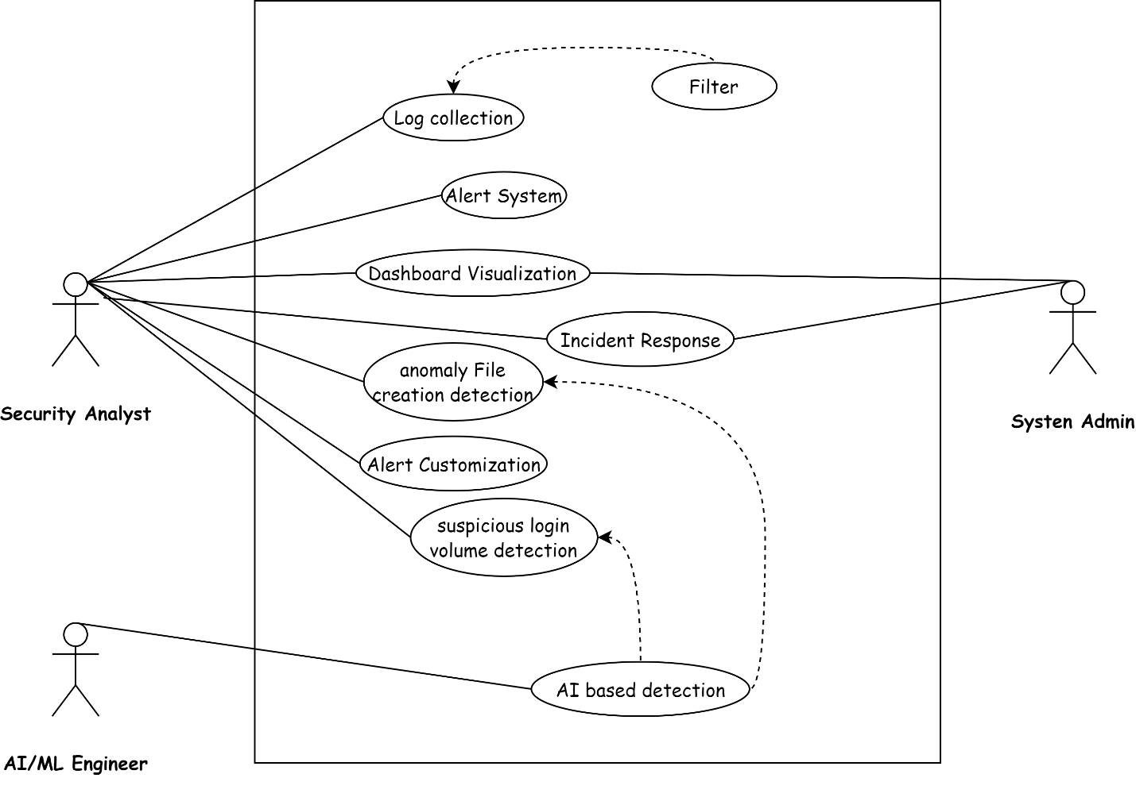*Figure: 01***

## 9. Summary

This document describes an AI-powered anomaly detection system using Wazuh and the Elastic Stack to identify unusual activities, such as *anomalous file creation* and *suspicious login attempts*. The system uses Artificial intelligence for automatic detection, real-time monitoring, and instant alerts, with a clear visualization of data on Kibana dashboards.

Designed for security analysts, system administrators, and AI engineers, it offers features like log collection, customizable alerts, and incident reporting. It supports multiple platforms, scales with growing data, and integrates with other security tools. The system provides clear dashboards and email notifications to keep users informed.

Two key use cases detecting *unusual file creation* and *suspicious logins* demonstrate how it helps security teams respond quickly and effectively

.